**535/1**

**PHYSICS**

**Paper 1**

**2024**

2 **hours**

**TRIAL TEST II 2024**

**S.4 Physics**

**Paper 1**

**2hours**

**INSTRUCTIONS:**

*This paper consists of* **two** *sections*; **A** *and* **B** *It has* **six** *examination items***.**

*Section* **A** *has* **three** *compulsory items.*

*Section* **B** *has* **two** *parts;* **I** *and* **II***. Answer* **one** *item from* **each** *part.*

*Answer* **five** *items in all.*

**SECTION A**

**Attempt all items in section**

**Item 1**

During an English lesson in senior two which normally takes place in the **school main hall,** Joan one of the students has always been complaining that when she **sits in front**, **she is unable to see** letters on the chalkboard clearly, she always wants to seat at the back of the class but the English teacher doesn't allow her to sit at the back thinking that she will not be attentive. Ketra is also a student in this class, she found out that whenever the **main hall is empty, and** noise is made, a lot of **repeated sound** is heard which is never heard when the main hall is full of students, this has always puzzled her

**TASK**

As the a physics student help and explain to;

a) The English teacher and the entire class the reason why Joan is **unable to see** clearly when she sits in front of the class and what should be done to solve this problem

b) Ketra the cause of the repeated sounds when the hall is empty

(12 scores)

**Item 2**

A certain group of people discovered a precious mineral in a certain part of the country. A team of men picked samples and kept them in a store of one of the hospitals where photographic plates are also stored. The mineral was checked regularly and the following observations were made.

* All photographic plates were darkened.
* Its mass reduced spontaneously with time as shown below,

|  |  |  |  |  |  |
| --- | --- | --- | --- | --- | --- |
| Mass (g) | 200 | 150 | 70 | 35 | 25 |
| Time (days) | 0 | 4 | 16 | 28 | 30 |

As a physics learner,

1. Support the view that the mineral is radioactive.
2. Use the graph to estimate its half life
3. Explain the best way of storing this rare mineral
4. What are the dangers of exposing this mineral to the public (12 scores)

**Item 3**

On a certain day at around 1:30pm while in the dining hall, learners watched heavy fog-rains and floods being experienced in a certain outside country on an international T.V live channel. To worsen matters, the floods were happening at night and this risked many natives as many of them were ambushed while asleep. Learners wondered how it would be night and seriously raining in an area yet it was day and the Sun was highly shinning at that time in their school.

**Task:**

As physics learner help the learners clear their queries about;

a) Occurrence of the floods in one area yet it was shining in their school at same time.

b) Why it was night in that outside country yet it was day-time in their area?

c) How T.V signals broadcast from where the floods were happening reached them.

(12 scores)

**SECTION B**

**PART I**

**Attempt only one item from this part.**

**Item 4**

During the prom party, two liters of water at 240C were served to Anita and Arthur. They both raised their complaint that the water was too hot for them to drink, the organizer responded to them by offering them a 50g ice cube at -100C .They mixed the water and the ice cube in a container of negligible specific heat capacity. They were later surprised by the disappearance of the ice cube in water. The two friends later put water in two different containers of specific heat capacities 8000jkg-1k-1 and 15000JKg-1K-1. They were again surprised to find their water at different temperatures after a short break

Hint:

Specific heat capacity of water = 4200JKg-1k-1

Latent heat of fusion of ice = 340,000JKg-1

Use your knowledge of physics to:

1. Determine if the water cooled when mixed with ice
2. Why do the ice cubes disappeared when mixed with water?
3. Explain why there was a difference in in temperatures in the water left in different containers.

**(12 marks)**

**Item 5**

During the midday heat of an extremely hot day, district engineers made a visit to a construction site situated near a primary school. However, one of the engineers expressed concern about a foul odor coming from the primary school latrines. This prompted him to approach the school administrators, who admitted their lack of knowledge regarding the cause of the odor spread, attributing it to hot weather conditions beyond their control. A week later the engineers presented their findings:

* Some construction materials lacked sufficient mechanical properties.
* Carrying concrete on their heads posed a risk to the builder’s safety. They urged them to continue using concrete however recommended reinforcing concrete for increased strength.
* A small material of the same type as the iron bars used at the site measuring 14𝑐𝑚 in length, exhibited an extension of 0.3𝑐𝑚 when subjected to a load of 20𝑘𝑔.

This information caused confusion among the builders.

**Hint:** *The diameter of the iron sample material (having the same properties as the iron bars used at the site) was* 7×10−2𝑚𝑚 **,***the recommended iron bars should have a Young’s modulus of at least* 4.0×109𝑁𝑚−1*, acceleration due to gravity, g =* 10𝑚𝑠−2

**Task:**

Having acquired some physics knowledge, **help**

a) The builders understand

i) The emphasized mechanical properties highlighted in the report.

ii) Why they urged them to continue using concrete, what it means by reinforcing concrete and suggest alternative methods for transporting concrete to higher floors.

b) The builders evaluate whether the iron bars used were suitable for construction of such structures.

c) The school administrators understand why the odor could spread much during hot days and provide strategies to minimize the odor spread **(12scores)**

**PART II**

**Attempt only one item from this part**

**Item 6**

The head teacher of a certain school has just bought posho for students to eat which is claimed to be containing some small metallic particles which can be deadly to student’s lives.

He is confused about what to do with the posho and has already spent the school’s money to buy it and cannot return it to the shop.

Support material.

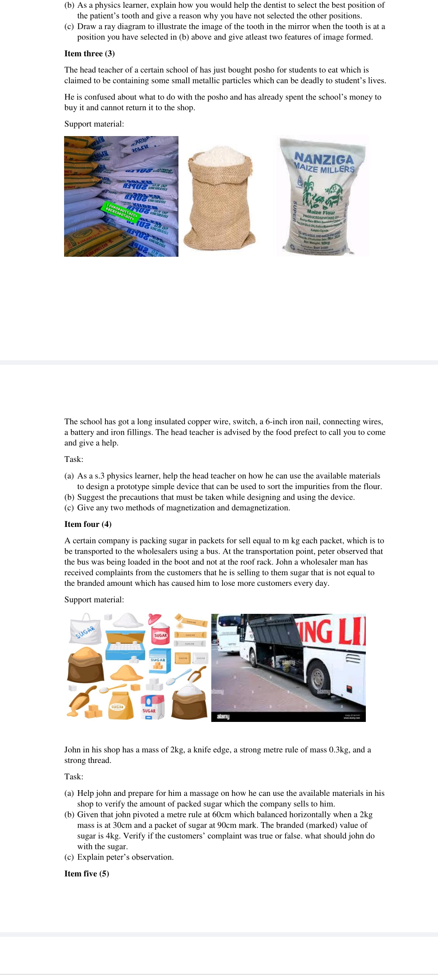

The school has got a long insulated copper wire, switch, a 6-inch iron nail, connecting wires, a battery and iron fillings. The head teacher is advised by the food prefect to call you to come and give a help.

Task:

(a) As a physics learner, help the head teacher on how he can use the available materials to design a prototype simple device that can be used to sort the impurities from the flour.

(b) Suggest the precautions that must be taken while designing and using the device.

(c) Give any two methods of magnetization and demagnetization.

**Item 7**

The welders in a certain workshop are troubled with their tools being shocked by electricity from a generator of **240V**. When they visited a technician, they were advised to wind a copper wire to **3000** turns around a soft iron ring on the receiving part so as to output **120V** suitable for their work shop operations fixed in a box. However, the welders seem bothered of how this will be of help.

**Task**

As a learner of physics,

(a) Explain to the welders how the above design will produce power corresponding to their consumption.

(b) Help the welder to determine the number of turns to be wound on the output part of the device

(c) Comment on how efficient the device is if the ratio of current output to current input is **1.5**

(d) Advise the welders on how to improve the efficiency of the device

**END**